

**UNIVERSITY INSTITUTE OF ENGINEERING**

**Department of Computer Science & Engineering**

**Subject Name:** IOT Lab

**Submitted to: Submitted by:**

Er. Manni Kumar Name: Rahul Kumar

UID: 20BCS7081

Section: 716

Group: B

**INDEX**

|  |  |  |  |  |  |  |
| --- | --- | --- | --- | --- | --- | --- |
| **Ex. No** | **List of Experiments** | **Conduct (MM: 12)** | **Viva**  **(MM: 10)** | **Record (MM: 8)** | **Total**  **(MM: 30)** | **Remarks/Signature** |
| 1.1 | Familiarization with Arduino |  |  |  |  |  |
| 1.2 | Identification of different sensors used in IOT applications. |  |  |  |  |  |
| 1.3 | Demonstration of Autodesk Tinkercad Simulation Platform. |  |  |  |  |  |
| 2.1 | Program to interface the Arduino/Raspberry Pi with LED and blinking application. |  |  |  |  |  |
| 2.2 | To measure the distance of an object using an ultrasonic sensor. |  |  |  |  |  |
| 2.3 | Interfacing of Arduino/Raspberry Pi with temperature and humidity sensor with real time application. |  |  |  |  |  |
| 2.4 | To display data generated by sensor on LCD using Arduino/Raspberry Pi |  |  |  |  |  |
| 3.1 | Interfacing Air Quality Sensor (MQ135) and display data on LCD. |  |  |  |  |  |
| 3.2 | Real time application of controlling actuators through Bluetooth application using Arduino |  |  |  |  |  |
| 3.3 | Study the Implementation of Zigbee Protocol using Raspberry Pi/Arduino |  |  |  |  |  |

**Experiment1.1**

**Student Name: Rahul Kumar UID: 20BCS7081**

**Branch: CSE Section/Group: 716/B**

**Semester: 6th Date of Performance: 27 Feb 2023**

**Subject Name: IOT lab**

**Aim:**

Familiarization with Arduino hardware and perform necessary software installation.

# Objectives:

1. To study hardware and software related to IoT
2. To understand the function of Node MCU, Arduino Uno and Raspberry Pi.

**Script and Output:**

**Arduino Board:**

Arduino is an easy-to-use open platform to create electronics projects. Arduino boards play a vital role in creating different projects. It makes electronics accessible to non-engineers, hobbyists, etc.

The various components present on the Arduino boards are**Microcontroller, Digital Input/output pins, USB Interface and Connector, Analog Pins, Reset Button, Power button, LED's, Crystal Oscillator**, and**Voltage Regulator**. Some components may differ depending on the type of board.

The most standard and popular board used over time is **Arduino UNO**. The ATmega328 Microcontroller present on the UNO board makes it rather powerful than other boards. There are various types of Arduino boards used for different purposes and projects. The [Arduino](https://www.javatpoint.com/arduino) Boards are organized using the Arduino (IDE), which can run on various platforms. Here, IDE stands for Integrated Development Environment.

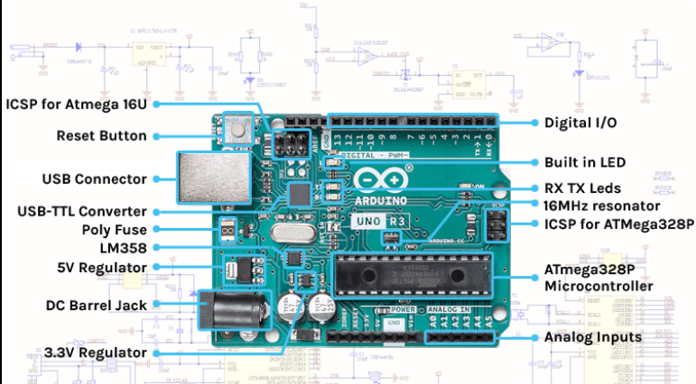

**Arduino Uno:**

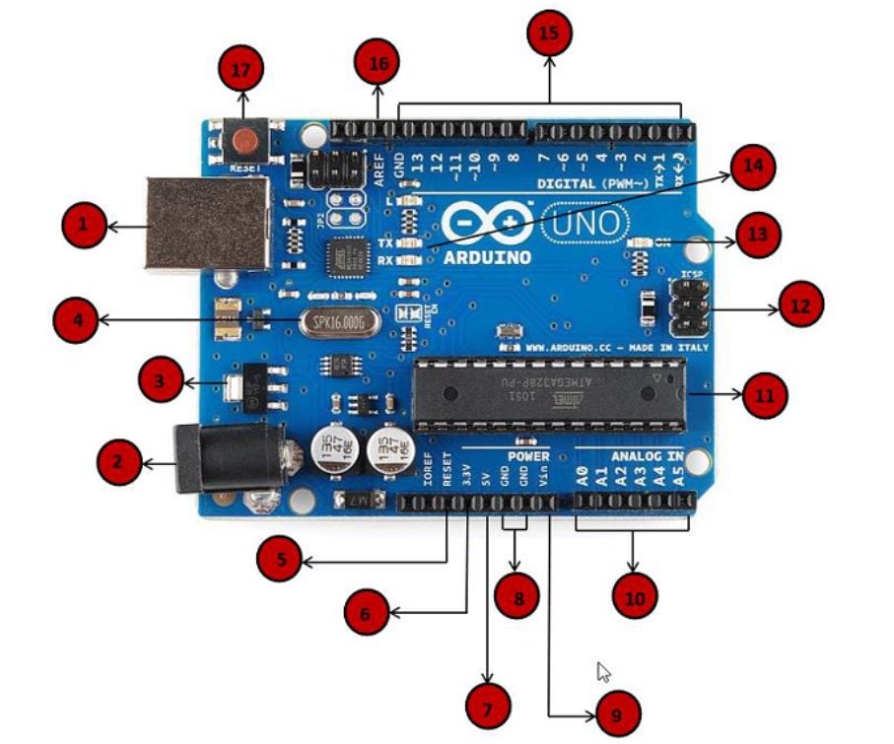

**Power USB**

Arduino board can be powered by using the USB cable from your computer. All you need to do is connect the USB cable to the USB connection (1).

**Power (Barrel Jack)**

Arduino boards can be powered directly from the AC mains power supply by connecting it to the Barrel Jack (2).

Voltage Regulator

**Voltage Regulator**

The function of the voltage regulator is to control the voltage given to the Arduino board and stabilize the DC voltages used by the processor and other elements.

Crystal Oscillator

**Crystal Oscillator**

The crystal oscillator helps Arduino in dealing with time issues. How does Arduino calculate time? The answer is, by using the crystal oscillator. The number printed on top of the Arduino crystal is 16.000H9H. It tells us that the frequency is 16,000,000 Hertz or 16 MHz.

Arduino Reset

**Arduino Reset**

You can reset your Arduino board, i.e., start your program from the beginning. You can reset the UNO board in two ways. First, by using the reset button (17) on the board. Second, you can connect an external reset button to the Arduino pin labelled RESET (5).

Pins

**Pins (3.3, 5, GND, Vin)**

* 3.3V (6) − Supply 3.3 output volt
* 5V (7) − Supply 5 output volt
* Most of the components used with Arduino board works fine with 3.3 volt and 5 volt.
* GND (8)(Ground) − There are several GND pins on the Arduino, any of which can be used to ground your circuit.
* Vin (9) − This pin also can be used to power the Arduino board from an external power source, like AC mains power supply.

Analog pins

**Analog pins**

The Arduino UNO board has six analog input pins A0 through A5. These pins can read the signal from an analog sensor like the humidity sensor or temperature sensor and convert it into a digital value that can be read by the microprocessor.

Main microcontroller

**Main microcontroller**

Each Arduino board has its own microcontroller (11). You can assume it as the brain of your board. The main IC (integrated circuit) on the Arduino is slightly different from board to board. The microcontrollers are usually of the ATMEL Company. You must know what IC your board has before loading up a new program from the Arduino IDE. This information is available on the top of the IC. For more details about the IC construction and functions, you can refer to the data sheet.

ICSP pin

**ICSP pin**

Mostly, ICSP (12) is an AVR, a tiny programming header for the Arduino consisting of MOSI, MISO, SCK, RESET, VCC, and GND. It is often referred to as an SPI (Serial Peripheral Interface), which could be considered as an "expansion" of the output. Actually, you are slaving the output device to the master of the SPI bus.

Power LED indicator

**Power LED indicator**

This LED should light up when you plug your Arduino into a power source to indicate that your board is powered up correctly. If this light does not turn on, then there is something wrong with the connection.

TX and RX LEDs

**TX and RX LEDs**

On your board, you will find two labels: TX (transmit) and RX (receive). They appear in two places on the Arduino UNO board. First, at the digital pins 0 and 1, to indicate the pins responsible for serial communication. Second, the TX and RX led (13). The TX led flashes with different speed while sending the serial data. The speed of flashing depends on the baud rate used by the board. RX flashes during the receiving process.

Digital I/O

**Digital I/O**

The Arduino UNO board has 14 digital I/O pins (15) (of which 6 provide PWM (Pulse Width Modulation) output. These pins can be configured to work as input digital pins to read logic values (0 or 1) or as digital output pins to drive different modules like LEDs, relays, etc. The pins labeled “~” can be used to generate PWM.

AREF

**AREF**

AREF stands for Analog Reference. It is sometimes, used to set an external reference voltage (between 0 and 5 Volts) as the upper limit for the analog input pins.

# Program an Arduino:

**Step 1** − First you must have your Arduino board (you can choose your favorite board) and a USB cable. In case you use Arduino UNO, Arduino Duemilanove, Nano, Arduino Mega 2560, or Diecimila, you will need a standard USB cable (A plug to B plug), the kind you would connect to a USB printer as shown in the following image.

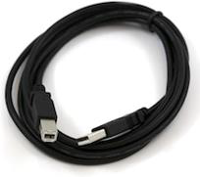

In case you use Arduino Nano, you will need an A to Mini-B cable instead as shown in the following image.

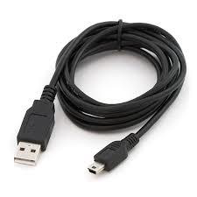

**Step 2 − Download Arduino IDE Software.**

You can get different versions of Arduino IDE from the [Download page](https://www.arduino.cc/en/Main/Software) on the Arduino Official website. You must select your software, which is compatible with your operating system (Windows, IOS, or Linux). After your file download is complete, unzip the file.

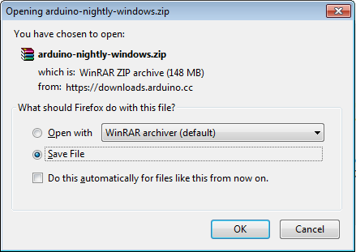

**Step 3 − Power up your board.**

The Arduino Uno, Mega, Duemilanove and Arduino Nano automatically draw power from either, the USB connection to the computer or an external power supply. If you are using an Arduino Diecimila, you have to make sure that the board is configured to draw power from the USB connection. The power source is selected with a jumper, a small piece of plastic that fits onto two of the three pins between the USB and power jacks. Check that it is on the two pins closest to the USB port.

Connect the Arduino board to your computer using the USB cable. The green power LED (labeled PWR) should glow.

**Step 4 − Launch Arduino IDE.**

After your Arduino IDE software is downloaded, you need to unzip the folder. Inside the folder, you can find the application icon with an infinity label (application.exe). Double-click the icon to start the IDE.

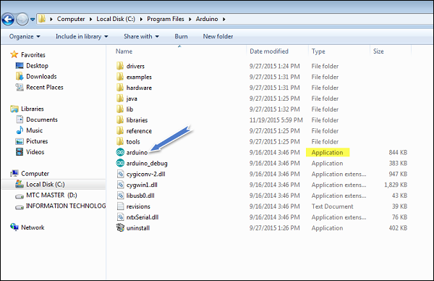

**Step 5 − Open your first project.**

Once the software starts, you have two options −

* Create a new project.
* Open an existing project example.

To create a new project, select File → **New**.

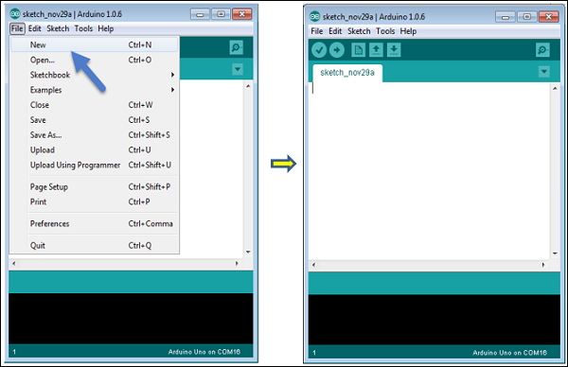

To open an existing project example, select File → Example → Basics → Blink.

Open Project

Here, we are selecting just one of the examples with the name **Blink**. It turns the LED on and off with some time delay. You can select any other example from the list.

**Step 6 − Select your Arduino board.**

To avoid any error while uploading your program to the board, you must select the correct Arduino board name, which matches with the board connected to your computer.

Go to Tools → Board and select your board.

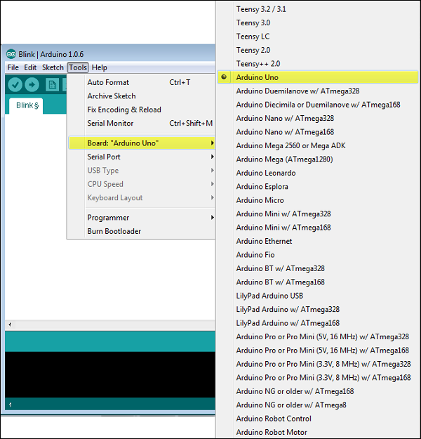

Here, we have selected Arduino Uno board according to our tutorial, but you must select the name matching the board that you are using.

**Step 7 − Select your serial port.**

Select the serial device of the Arduino board. Go to **Tools → Serial Port** menu. This is likely to be COM3 or higher (COM1 and COM2 are usually reserved for hardware serial ports). To find out, you can disconnect your Arduino board and re-open the menu, the entry that disappears should be of the Arduino board. Reconnect the board and select that serial port.

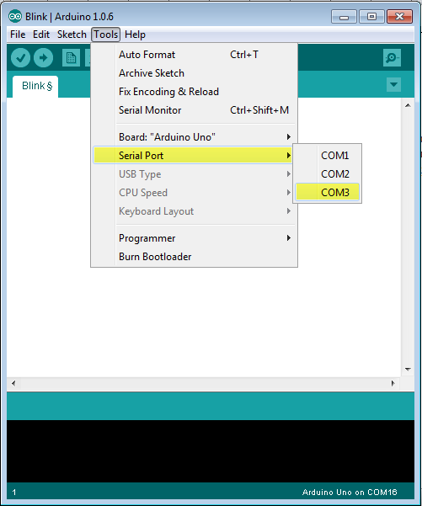

**Step 8 − Upload the program to your board.**

Before explaining how we can upload our program to the board, we must demonstrate the function of each symbol appearing in the Arduino IDE toolbar.

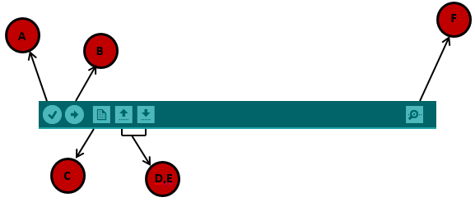

**A** − Used to check if there is any compilation error.

**B** − Used to upload a program to the Arduino board.

**C** − Shortcut used to create a new sketch.

**D** − Used to directly open one of the example sketch.

**E** − Used to save your sketch.

**F** − Serial monitor used to receive serial data from the board and send the serial data to the board.

Now, simply click the "Upload" button in the environment. Wait a few seconds; you will see the RX and TX LEDs on the board, flashing. If the upload is successful, the message "Done uploading" will appear in the status bar.

# Basic Adruino functions are:

The functions allow a programmer to divide a specific code into various sections, and each section performs a particular task. The functions are created to perform a task multiple times in a program.

The function is a type of procedure that returns the area of code from which it is called.

For example, to repeat a task multiple times in code, we can use the same set of statements every time the task is performed.

1. digitalRead(pin): Reads the digital value at the given pin.
2. digitalWrite(pin, value): Writes the digital value to the given pin.
3. pinMode(pin, mode): Sets the pin to input or output mode.
4. analogRead(pin): Reads and returns the value.
5. analogWrite(pin, value): Writes the value to that pin.
6. serial.begin(baud rate): Sets the beginning of serial communication by setting the bit rate.

### **Advantages of using Functions**

Let's discuss some advantages of using functions in programming, which are listed below

* It increases the readability of the code.
* It conceives and organizes the program.
* It reduces the chances of errors.
* It makes the program compact and small.
* It avoids the repetition of the set of statements or codes.
* It allows us to divide a complex code or program into a simpler one.
* The modification becomes easier with the help of functions in a program.

The [Arduino](https://www.javatpoint.com/arduino) has two common functions **setup()** and **loop(),** which are called automatically in the background. The code to be executed is written inside the curly braces within these functions.

**void setup()** - It includes the initial part of the code, which is executed only once. It is called as the **preparation block**.

**void loop()** - It includes the statements, which are executed repeatedly. It is called the **execution block**.